**Levels of testing**

We studied about **"Fundamental test process"** where we talked about the stages that comes along while performing testing activities in the earlier pages. While following the process actual testing activities are executed in levels. Below mentioned table shows those levels along with their required details:

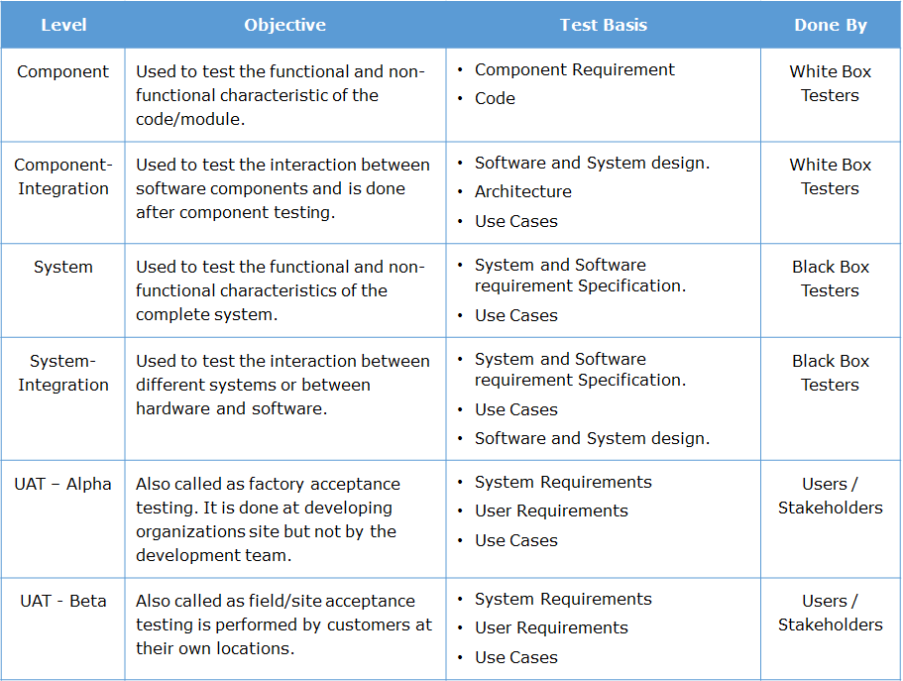

### ****1️⃣ Unit Testing****

* **Purpose:** Test individual components or functions of the software.
* **Performed by:** Developers.
* **Focus:** Verifying that each unit of the software performs as expected.
* **Tools:** JUnit (Java), NUnit (.NET), PyTest (Python).
* **Key Points:**
  + Fast and automated.
  + Tests smallest pieces of code (methods, classes, functions).
  + Helps in early bug detection.

### ****2️⃣ Integration Testing****

* **Purpose:** Test the interaction between integrated modules.
* **Performed by:** Developers and testers.
* **Focus:** Ensuring that data flows correctly between modules.
* **Types:**
  + **Top-down:** Testing from top-level modules to lower ones.
  + **Bottom-up:** Testing from lower-level modules to higher ones.
  + **Big Bang:** Testing all modules together after integration.
* **Tools:** JUnit with Mockito, Postman (for API integration), Selenium.
* **Key Points:**
  + Detects interface issues.
  + Validates communication between modules.

### ****3️⃣ System Testing****

* **Purpose:** Validate the complete and integrated system.
* **Performed by:** Independent testing team.
* **Focus:** Checking that the system meets specified requirements.
* **Includes:**
  + Functional testing (e.g., UI, APIs, database).
  + Non-functional testing (e.g., performance, security).
* **Tools:** Selenium, JMeter, LoadRunner.
* **Key Points:**
  + Black-box testing approach.
  + Verifies end-to-end scenarios.

### ****4️⃣ Acceptance Testing****

* **Purpose:** Validate the system against business requirements.
* **Performed by:** End-users, stakeholders, or testers.
* **Focus:** Ensuring the software is ready for deployment.
* **Types:**
  + **User Acceptance Testing (UAT):** Conducted by clients/users.
  + **Business Acceptance Testing (BAT):** Checks business rules.
  + **Alpha Testing:** Performed at the developer’s site.
  + **Beta Testing:** Performed by real users in the production environment.
* **Tools:** Cucumber (for BDD), Selenium.
* **Key Points:**
  + Final verification before release.
  + Focuses on real-world usage.

### ****📌 Summary of Testing Levels****

| **Level** | **Goal** | **Who Performs** | **Focus Area** |
| --- | --- | --- | --- |
| Unit Testing | Validate individual components | Developers | Code logic, functions |
| Integration Testing | Validate interaction between units | Developers/Testers | Interfaces, data flow |
| System Testing | Validate entire system | QA/Testers | System behavior, requirements |
| Acceptance Testing | Validate system for end-users | Users/Stakeholders | Business needs, usability |

### ****💡 Key Insights:****

* Testing levels help detect bugs at various stages, reducing overall cost and time.
* Early testing (like Unit and Integration) is cheaper and faster.
* Later stages (like System and Acceptance) ensure the product meets end-user needs.